BBC Club Prospero Society and Retired Members

Dear Prospero Member,
Another good quarters of events, we are so lucky to have Gayner with a zest for new adventurers, experiences and learning. Please remember this is our Group and although some members are brilliant at suggesting places to go and things to do, we could use lots more. It is important to remember, if your suggestion does not materialise it will be for a reason. Consideration is always taken for ease of access, to the location and within the building, timing, as some members travel from outside of London and the fares are too excessive to travel before 9.30am. Please be understanding, and another reminder to volunteer to be a coordinator, if you are going to the event we are thankful for the extra effort.
It is always a pleasure to meet members face to face at the events and a gracious afternoon tea we had at the Strand Palace Hotel. I noticed some went home with a doggy bag!
I look forward to our Christmas lunch which at time of writing is next week and to all members I wish you a Merry Christmas and a very Happy New Year. Hope to see you at the next quarters events.
Carol Elliott
Chairman, BBC Prospero Society.
A quick word about bookings: if a deadline is quoted this is the date that final numbers and payment has to be made to the venue. However, some venues restrict numbers and if this quota is exceeded before the deadline then a first come first served basis is adopted with Prospero members getting one week’s priority booking. Availability is updated regularly on the website. In the event that a trip is overbooked then names will be added to a waiting list. Refunds after the booking deadline will only be made if the space is filled from the waiting list.
BBC Club will be transferring to a new membership database in early 2020 which will also change the online booking software. Consequently no events are bookable on line this quarter.

This newsletter is also available to download and view or print online. http://www.bbcclub.com/connect/prospero
PS – sorry the February events are so close together! That’s just the way it worked out!
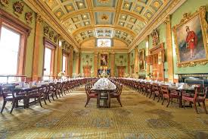
Fishmongers Hall Tour
London Bridge LONDON EC4R 9EL
Monday 27th January 2.00pm
Fishmongers’ Hall is one of the most historic, beautiful and sought-after venues in the City. The Fishmongers’ Company is one of the Twelve Great Livery Companies of the City of London, and among the most ancient of the City Guilds. For over 700 years the Fishmongers have upheld standards in the trading of fish and shellfish and supported the fisheries industry. Fishmongers’ Hall was destroyed by the Great Fire, rebuilt twice thereafter and then devastated by bombs during World War II but restored to its former glory.
After a welcome of tea/coffee and biscuits, find out more about some of the defining moments in the Fishmongers story so far including medieval charters and trading, and modern history since the Great Fire.
Prospero Members £15 per person
Club members and Guests £18 per person
Strictly Limited availability! Booking Deadline: 9th January 2020
A Coordinator is needed for this trip. Please indicate if you are willing to act as such.
…………………………………………………………………………………………………
Application for Fishmongers Hall
Name.................................... …………………………………………………………

Phone no:-............................................e-mail......................................................

Prospero Member @ £15 ............ Member and Guests @£18...............

Total Amount £………………

Please write a cheque for the full amount to BBC Club Sports & Leisure Ltd and post it with the application and any guest name(s) to Gayner Leach, BBC Club, BC2 B3 Broadcast Centre, 201 Wood Lane, London W12 7TP. Please include your email address for confirmation letter and if you are unsuccessful your cheque will be destroyed.
Alternatively please include an SAE marked for full details of the trip or returned cheque if fully booked

Duke of York's HQ, King's Road, London SW3 4RY

This is a self-guided tour of this exceptionally popular exhibition. There will be standing and queuing, including outside to get in. The gallery has extremely limited seating. The exhibition commemorates the 100th anniversary of the discovery of Tutankhamun's tomb, and is the final chance to see these glittering world heritage artefacts before they return to Egypt forever.
Explore the life of King Tutankhamun, and the storied discovery that captivated the world, through more than 150 authentic pieces from the tomb - more than 60 of which are travelling outside of Egypt for the first time.
This is a once in a lifetime opportunity to experience the wonder and mystery of the boy king before his priceless objects return to Egypt forever.

Tuesday 25th February
11.30am
Prospero Members £20.00 Club Members and Guests £24.00
Strictly Limited availability! Booking Deadline: 9th January 2020
A Coordinator is needed for this trip. Please indicate if you are willing to act as such.
………………………………………………………………………………………………………………………………………………..
Application for Tutankhamun

Name.................................... …………………………………………………………

Phone no:-............................................e-mail......................................................

Prospero Member@ £20.00 ............ Club members and guests@ £24.00....................

Total Amount £…………

Please write a cheque for the full amount to BBC Club Sports & Leisure Ltd and post it with the application and any guest name(s) to Gayner Leach, BBC Club, BC2 B3 Broadcast Centre, 201 Wood Lane, London W12 7TP. Please include your email address for confirmation letter and if you are unsuccessful your cheque will be destroyed.
Alternatively please include an SAE marked for full details of the trip or returned cheque if fully booked
Phoenix Theatre, Charing Cross Road, London WC2H 0JP

This joyous new musical shares the incredible real-life story of the 7,000 air passengers from all over the world who were grounded in Canada during the wake of 9/11 and the small Newfoundland community that invited these ‘e from aways’ into their lives.
(Thoroughly recommended ! – Gayner)

Wednesday 26th February
2.30pm
Dress circle rows D – G (best for accessibility).
Prospero Members £30 per person
Club members and Guests £35 per person
A Coordinator is needed for this trip. Please indicate if you are willing to act as such.
Strictly Limited availability! I have been given a deadline for payment of 16th December! I will try to extend this nearer the time depending on response.
....................................................................................................................
Come From Away

Name.................................... …………………………………………………………

Phone no:-............................................e-mail......................................................

Prospero Member @ £xx ............ Club Member/guest @ £xx.................

Total Amount £………………

Please write a cheque for the full amount to BBC Club Sports & Leisure Ltd and post it with the application and any guest name(s) to Gayner Leach, BBC Club, BC2 B3 Broadcast Centre, 201 Wood Lane, London W12 7TP. Please include your email address for confirmation letter and if you are unsuccessful your cheque will be destroyed.
Alternatively please include an SAE marked for full details of the trip or returned cheque if fully booked

Artisan Baking Course

Canary Wharf

A 3 hour exclusive workshop at Ann Smart’s school of cookery

Get ready to work with your hands to turn fresh and local ingredients into delicious artisanal fare under the instruction of a professional chef and bake like never before with this Artisan Baking Class at Ann's Smart School of Cookery. Everyone will be asked to join the chef in small groups. At times it’ll be hands-on at the front of the class, with a few members of your group and a chef by your side, while at others you’ll watch the chef and some of the other participants cook so you can enjoy taster dishes of their labour before attempting it yourself at home. From focaccia bread to hot cross buns and churros with hot chocolate and chilli to Ann’s chicken and mushroom pie, there’s all sorts of delicious baked treats that you’ll get to try, all coupled with Ann’s tips and tricks to make life easier and even more flavourful.

Tuesday 3rd March at 2.00pm

Prospero Members £50.00 Club Members and Guests £60.00
Booking Deadline: 6th January
You will make:
- Focaccia bread
- Scones
- Custard tarts
- Seasonal berry crepes
- Ann’s chicken and mushroom pie
- Ann’s lemon drizzle cake
- Citrus meringue quiffs

......................................................................................................................................................
Artisan Baking Course Application

Name............................................

Phone/e-mail.........................................................

Prospero members @ £50.00................. Club members/guest @£60.00........ Total enclosed £........................

Please write a cheque for the full amount to BBC Club Sports & Leisure Ltd and post it with the application and any guest name(s) to Gayner Leach, BBC Club, BC2 B3 Broadcast Centre, 201 Wood Lane, London W12 7TP. Please include your email address for confirmation letter and if you are unsuccessful your cheque will be destroyed.
Alternatively please include an SAE marked for full details of the trip or returned cheque if fully booked

Tour of the Royal College of Arms

Gildea St, London, W1

Thursday 19th March 6.30pm

A unique chance to hear about the College and explore its unique collections with the Officer in Waiting who will speak about the history of heraldry and the role of the Heralds, a little about the architecture of the building and how they run their practices. You then spend a good hour in the Record Room where you will be shown a selection of College records and other manuscripts dating back to 1484. Then would be an opportunity to sit down and have a glass of wine or soft drink during a talk about the architecture and practices.

Cost: Prospero £18.00 Members /Guests £20.00

Note from the Officer: Regrettably I must warn you that as the College is a very old building, it was built without access for the disabled in mind: there are ten or so steps up to the main entrance, and toilets are on the third floor of another staircase.

Strictly Limited availability! Booking Deadline: 1st March 2020
A Coordinator is needed for this trip. Please indicate if you are willing to act as such.

………………………………………………………………………………………….
Application for Royal College of Arms.

Name.................................... …………………………………………………………

Phone no:-............................................e-mail......................................................

Prospero Member @ £18.00 ............ Club Member/guest @£20.00....................Total enclosed £........................

Please write a cheque for the full amount to BBC Club Sports & Leisure Ltd and post it with the application and any guest name(s) to Gayner Leach, BBC Club, BC2 B3 Broadcast Centre, 201 Wood Lane, London W12 7TP. Please include your email address for confirmation letter and if you are unsuccessful your cheque will be destroyed.
Alternatively please include an SAE marked for full details of the trip or returned cheque if fully booked.

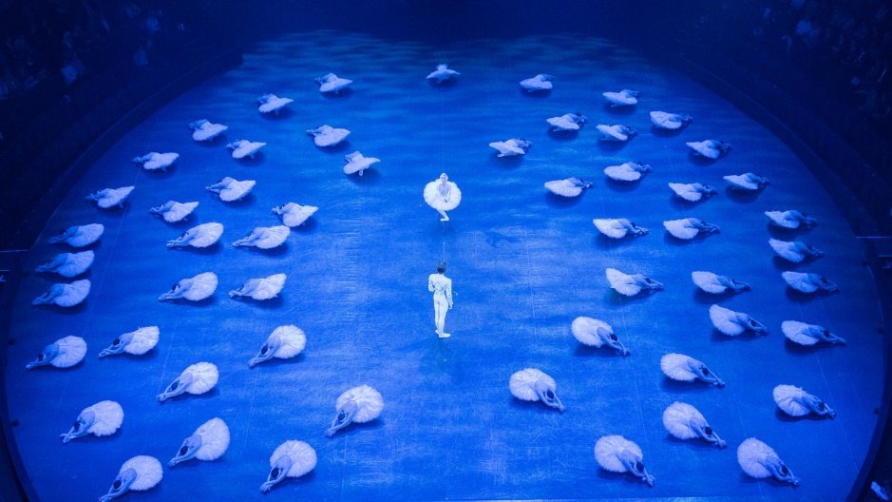
English National Ballet and Royal Albert Hall Present:
SWAN LAKE in the Round
Thursday 25th June 2020 2.30pm
Royal Albert Hall
Front row of the circle – there is a lift!
Prospero Members £35.00 Club Members and Guests £38.00
Last few Tickets remaining!

………………………………………………………………………………..
Application for SWAN LAKE

Name.................................... …………………………………………………………

Phone no:-............................................e-mail......................................................

Prospero Member@ £35.00 ............ guests@ £38.................. Total Amount £…………

Please write a cheque for the full amount to BBC Club Sports & Leisure Ltd and post it with the application and any guest name(s) to Gayner Leach, BBC Club, BC2 B3 Broadcast Centre, 201 Wood Lane, London W12 7TP. Please include your email address for confirmation letter and if you are unsuccessful your cheque will be destroyed.
Alternatively please include an SAE marked for full details of the trip or returned cheque if fully booked

